Feature Engineering - Numerical Transformations

Numerical Transformation Introduction
8 min
We’ve all heard it; a lot of work goes into getting your data just right for the task you have at hand. Perhaps you are trying to find insight into customer behavior or predicting the best time to send a marketing email. Whatever problem you may be trying to solve - you have probably already spent some time wrangling your data and getting it just right, and now you are at the stage where you need to prepare your data for machine learning.
For example, some machine learning models, like logistic regression and neural networks, can only handle numbers. Then random forest and decision tree models can take both numbers and text. We will call these text features categorical data, but more on that later. We also need to understand the spread of our data, as some models have a tough time handling data that has extreme outliers.
This process is called numerical transformation, when we take our numerical data and change it into another numerical value. This is meant to change the scale of our values or even adjust the skewness of our data. You may be thinking, “we already have our data in numbers. Why would we want to change those?” Well, first of all, that is a great question. We’ll dive deep into the “why we do this” throughout this lesson. To put it simply, we do this to help our model better compare features and, most importantly, improve our model’s accuracy and interpretability. That sounds like some good reasons to put the time and effort into numerical transformations if I do say so myself.
We’ll focus on the following numerical transformations:
- Centering
- Standard Scaler
- Min and Max Scaler
- Binning
- Log transformations
Let’s get to know the data frame we will be using. This dataset has just over 100 responses from customers where they were asked about a recent Starbucks experience. You will soon notice that we have a mix of numerical and categorical data, but we’ll focus only on the numerical features for this lesson.
Instructions
- Checkpoint 1 PassedWe have provided you with a csv file under the name starbucks_customers.csv and have already imported pandas for you. Import the file and set it to a variable called coffee.
- Checkpoint 2 PassedExamine the features in your new data frame by printing the columns.
- Checkpoint 3 PassedLook at each feature within your data frame by printing .info()
import pandas as pd ## add code below## set up dataframecoffee = pd.read_csv('starbucks_customers.csv')## print the column namesprint(coffee.columns)## get information on your dataprint(coffee.info())
Index(['spent', 'nearest_starbucks', 'age', 'rate_quality', 'rate_price', 'rate_promo', 'ambiance', 'wifi', 'service', 'meetings_hangout'], dtype='object')<class 'pandas.core.frame.DataFrame'>RangeIndex: 122 entries, 0 to 121Data columns (total 10 columns):spent 122 non-null int64nearest_starbucks 122 non-null int64age 122 non-null int64rate_quality 122 non-null int64rate_price 122 non-null int64rate_promo 122 non-null int64ambiance 122 non-null int64wifi 122 non-null int64service 122 non-null int64meetings_hangout 122 non-null int64dtypes: int64(10)memory usage: 9.7 KBNone

Centering Your Data
15 min
Data centering involves subtracting the mean of a data set from each data point so that the new mean is 0. This process helps us understand how far above or below each of our data points is from the mean.
We can look at the nearest_starbucks column.
distance = coffee['nearest_starbucks']Copy to Clipboard
We will find the mean of our feature, create one line of code to center our data, and then plot the centered data. Here’s what it will look like in Python.
#get the mean of your featuremean_dis = np.mean(distance)#take our distance array and subtract the mean_dis, this will create a new series with the resultscentered_dis = distance - mean_dis#visualize your new listplt.hist(centered_dis, bins = 5, color = 'g')#label our visualplt.title('Starbucks Distance Data Centered')plt.xlabel('Distance from Mean')plt.ylabel('Count')plt.show();Copy to Clipboard

Now, look at that! Our data is centered at 0 and we can see the spread of data, many of our customers who took the survey tend to live fairly close to a Starbucks.
Let’s try centering our age feature to see what happens there.
Instructions
- Checkpoint 1 PassedStart by setting your age feature to a variable called ages
- Checkpoint 2 PassedIt’s helpful to know both the minimum and maximum age in our feature. First, create a variable called min_age and print the value
- Checkpoint 3 PassedNow find the maximum age and set it to a variable called max_age and print the value.
- Checkpoint 4 PassedWe want to better understand the spread of our data, so print the difference between min_age and max_age
- Checkpoint 5 PassedWe will need the mean age of our feature to center our data around, so create a variable called mean_age and print that value.
- Checkpoint 6 PassedLet’s center our data! Set the result to a variable called centered_ages and print the results.
- Checkpoint 7 PassedPlot your centered data as a histogram.
import pandas as pdimport numpy as npimport matplotlib.pyplot as plt import codecademylib3_seaborn coffee = pd.read_csv('starbucks_customers.csv')## add code below## create ages variableages = coffee['age']## get min and printmin_age = np.min(ages)print(min_age)## get max and printmax_age = np.max(ages)print(max_age)## print the rangeprint(max_age - min_age)## find the meanmean_age = np.mean(ages)print(mean_age)## center agescentered_ages = ages - mean_ageprint(centered_ages)## graph itplt.hist(centered_ages)plt.show();
 | age
0 | 24.66393442622951
1 | 7.66393442622951
2 | 1.6639344262295097
3 | 0.6639344262295097
4 | 0.6639344262295097
5 | 0.6639344262295097
6 | -0.3360655737704903
7 | -1.3360655737704903
8 | -1.3360655737704903
9 | -1.3360655737704903
10 | 23.66393442622951
11 | -1.3360655737704903
12 | -5.33606557377049
13 | -6.33606557377049
14 | -10.33606557377049
15 | -12.33606557377049
16 | -14.33606557377049
17 | 37.66393442622951
18 | 14.66393442622951
19 | 7.66393442622951
20 | 1.6639344262295097
21 | 1.6639344262295097
22 | -0.3360655737704903
23 | -4.33606557377049
24 | -6.33606557377049
25 | 42.66393442622951
26 | 13.66393442622951
27 | 12.66393442622951
28 | 9.66393442622951
29 | 6.66393442622951
30 | -2.3360655737704903
31 | -4.33606557377049
32 | -7.33606557377049
33 | -7.33606557377049
34 | -7.33606557377049
35 | -13.33606557377049
36 | 0.6639344262295097
37 | 10.66393442622951
38 | 4.66393442622951
39 | 1.6639344262295097
40 | -4.33606557377049
41 | -4.33606557377049
42 | -4.33606557377049
43 | -6.33606557377049
44 | -7.33606557377049
45 | -8.33606557377049
46 | -12.33606557377049
47 | -12.33606557377049
48 | -4.33606557377049
49 | -5.33606557377049
50 | -11.33606557377049
51 | -1.3360655737704903
52 | -7.33606557377049
53 | 24.66393442622951
54 | 4.66393442622951
55 | 1.6639344262295097
56 | -3.3360655737704903
57 | -4.33606557377049
58 | -3.3360655737704903
59 | -5.33606557377049
60 | -6.33606557377049
61 | -11.33606557377049
62 | -4.33606557377049
63 | -5.33606557377049
64 | 2.6639344262295097
65 | 16.66393442622951
66 | 10.66393442622951
67 | 3.6639344262295097
68 | 2.6639344262295097
69 | 1.6639344262295097
70 | 0.6639344262295097
71 | -2.3360655737704903
72 | -2.3360655737704903
73 | -3.3360655737704903
74 | -5.33606557377049
75 | -6.33606557377049
76 | -7.33606557377049
77 | -7.33606557377049
78 | -8.33606557377049
79 | -10.33606557377049
80 | -14.33606557377049
81 | 17.66393442622951
82 | 14.66393442622951
83 | 12.66393442622951
84 | 10.66393442622951
85 | -0.3360655737704903
86 | -0.3360655737704903
87 | -1.3360655737704903
88 | -1.3360655737704903
89 | -1.3360655737704903
90 | -4.33606557377049
91 | -4.33606557377049
92 | -4.33606557377049
93 | -5.33606557377049
94 | -6.33606557377049
95 | 13.66393442622951
96 | 10.66393442622951
97 | 6.66393442622951
98 | 6.66393442622951
99 | 5.66393442622951
100 | 3.6639344262295097
101 | 1.6639344262295097
102 | 1.6639344262295097
103 | 1.6639344262295097
104 | 0.6639344262295097
105 | 0.6639344262295097
106 | -0.3360655737704903
107 | -0.3360655737704903
108 | -1.3360655737704903
109 | -1.3360655737704903
110 | -1.3360655737704903
111 | -1.3360655737704903
112 | -3.3360655737704903
113 | -3.3360655737704903
114 | -5.33606557377049
115 | -5.33606557377049
116 | -5.33606557377049
117 | -5.33606557377049
118 | -5.33606557377049
119 | -7.33606557377049
120 | -7.33606557377049
121 | -13.33606557377049

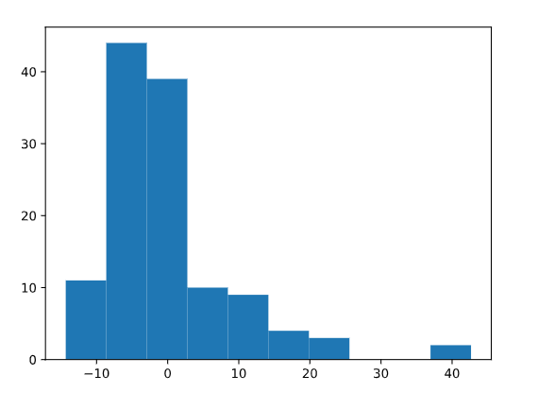

Standardizing our Data
14 min
Excellent work with centering the age feature from our dataset! Now we’ll take that concept one step further and discuss standardizing our data. Standardization (also known as Z-Score normalization) is when we center our data, then divide it by the standard deviation. Once we do that, our entire data set will have a mean of zero and a standard deviation of one. This allows all of our features to be on the same scale. How cool is that?
This step is critical because some
machine learning
Preview: Docs Loading link description
models will treat all features equally regardless of their scale. You’ll definitely want to standardize your data in the following situations:

- Before Principal Component Analysis
- Before using any clustering or distance based algorithmPreview: Docs Loading link description (think KMeans or DBSCAN)
- Before KNN
- Before performing regularization methods like LASSO and Ridge
If I wanted to see how customers rated quality vs. price, I could graph a scatter plot of those two features and easily see that customers tend to score those two questions closely. Notice the darker spots (meaning more data points are laying on top of one another) around the 3.0 for “Rate Quality” and 3.0 for “Rate Price” as an example. This insight was easy to see since our features are on the same one to five scale.

Now, what happens if I am working with features on two totally different scales? Perhaps the “customer age” and “how far they live from a Starbucks” feature? Let’s take a look.

Woah! Looking at this, it is much more challenging to gain insight or even identify patterns within our data. This will be a similar experience for our machine learning models. That’s why when we standardize our entire dataset, we tend to see a more robust model performance if all features are on the same scale.
Let’s examine one feature to learn the mathematics that goes on when we standardize our data. The mathematical formula will look like this:
z=value−meanstdevz=stdevvalue−mean​
We’ll look at just one feature, where customers were asked how close they are to their nearest Starbucks, and follow that formula above. First, we will set our nearest_starbucks feature to its own variable and then find the mean and standard deviation. Then we can quickly standard our list following the formula above.
distance = coffee['nearest_starbucks']#find the mean of our featuredistance_mean = np.mean(distance)#find the standard deviation of our featuredistance_std_dev = np.std(distance) #this will take each data point in distance subtract the mean, then divide by the standard deviationdistance_standardized = (distance - distance_mean) / distance_std_devCopy to Clipboard
We now have our distance feature standardized! Let’s double-check by seeing what the mean and standard deviation of our
array
Preview: Docs Loading link description
is.

# print what type distance_standardized isprint(type(distance_standardized))#output = <class 'pandas.core.series.Series'>#print the meanprint(np.mean(distance_standardized))#output = 7.644158530205996e-17#print the standard deviationprint(np.std(distance_standardized))#output = 1.0000000000000013Copy to Clipboard
Our outputs are basically mean = 0 and standard deviation = 1. Fantastic! Let’s see what our age feature looks like standardized.
Instructions
- Checkpoint 1 PassedFind the average of your variable ages and set the result to a variable called mean_age
- Checkpoint 2 PassedFind the standard deviation of your variable ages and set the result to a variable called std_dev_age
- Checkpoint 3 PassedStandardize our age column. Set the result to a variable called ages_standardized
- Checkpoint 4 PassedPrint the mean and standard deviation of ages_standardized.
import pandas as pdimport numpy as npcoffee = pd.read_csv('starbucks_customers.csv')ages = coffee['age']## add code below## set up your variablesmean_age = np.mean(ages)std_dev_age = np.std(ages)## standardize agesages_standardized = (ages - mean_age) / std_dev_age## print the results print(np.mean(ages_standardized))print(np.std(ages_standardized))

Standardizing our Data with Sklearn
11 min
Now that we understand the mathematics behind a standard scaler let’s quickly implement it with the sklearn library. We will begin by importing our StandardScaler library from sklearn.preprocessing.
from sklearn.preprocessing import StandardScalerscaler = StandardScaler()Copy to Clipboard
We instantiate the StandardScaler by setting it to a variable called scaler which we can then use to transform our feature. The next step is to reshape our distance
array
Preview: Docs Loading link description
. StandardScaler must take in our array as 1 column, so we’ll reshape our distance array using the .reshape(-1,1)
method
Preview: Docs Loading link description
. This numpy method says to take our data and give it back to us as 1 column, represented in the second value. The -1 asks numpy to figure out the exact number of rows to create based on our data. Pretty cool, right?

reshaped_distance = np.array(distance).reshape(-1,1)distance_scaler = scaler.fit_transform(reshaped_distance)Copy to Clipboard
Just like we learned in the last lesson, we do this so our data has a mean of 0 and standard deviation of 1. Let’s print to see how the StandardScaler did.
print(np.mean(distance_scaler))#output = -9.464196275493137e-17print(np.std(distance_scaler))#output = 0.9999999999999997Copy to Clipboard
You’ll notice the e-17 at the end of our output for the mean, and that is our number written in exponential notation. Written in standard notation our answer is -0.00000000000000009464196275493137. Which basically has the mean at 0 and our standard deviation = 1. Great work! Now you can try to standardize the age column with the new knowledge you just gained.
Instructions
- Checkpoint 1 PassedInstantiate StandardScaler by creating a variable named scaler
- Checkpoint 2 PassedReshape our ages feature and set the result to a variable named ages_reshaped
- Checkpoint 3 PassedNow we are ready to perform a .fit_transform on our ages_reshaped feature and set the results to the variable named ages_scaled
- Checkpoint 4 PassedPrint the mean and standard deviation of your new variable ages_scaled
import pandas as pdimport numpy as npfrom sklearn.preprocessing import StandardScaler coffee = pd.read_csv('starbucks_customers.csv')ages = coffee['age']## add code below## import standardscalerscaler = StandardScaler()## reshapeages_reshaped = np.array(ages).reshape(-1,1)## fit_transformages_scaled = scaler.fit_transform(ages_reshaped)## print mean and standard deviation print(np.mean(ages_scaled))print(np.std(ages_scaled))

Min-Max Normalization
10 min
Another form of scaling your data is to use a min-max normalization process. The name says it all, we find the minimum and maximum data point in our entire data set and set each of those to 0 and 1, respectively. Then the rest of the data points will transform to a number between 0 and 1, depending on its distance between the minimum and maximum number. We find that transformed number by taking the data point subtracting it from the minimum point, then dividing by the value of our maximum minus minimum.
Mathematically a min-max normalization looks like this:
Xnorm=X−XminXmax−XminXnorm​=Xmax​−Xmin​X−Xmin​​
One thing to note about min-max normalization is that this transformation does not work well with data that has extreme outliers. You will want to perform a min-max normalization if the range between your min and max point is not too drastic.
The reason we would want to normalize our data is very similar to why we would want to standardize our data - getting everything on the same scale.
We’d do this process to our entire data set, but lets look at our distance to a nearest Starbucks feature. We already know from earlier in this lesson that our range in this feature is not too large, so it is a good candidate for a min-max normalization. We’ll write a function that will perform the mathematics needed to transform the entire column.
distance = coffee['nearest_starbucks']#find the min value in our featuredistance_min = np.min(distance)#find the max value in our featuredistance_max = np.max(distance)#normalize our feature by following the formuladistance_normalized = (distance - distance_min) / (distance_max - distance_min)Copy to Clipboard
Excellent! Now if I were to print all the unique numbers in distance_norm here is what we will see.
{0.0, 0.125, 0.25, 0.375, 0.5, 0.625, 0.75, 0.875, 1.0}Copy to Clipboard
We can see that all numbers are between 0 and 1. Amazing!
Instructions
- Checkpoint 1 PassedWe will now work with the spent feature in our data frame. Take just that column and set it equal to a new variable called spent.
- Checkpoint 2 PassedFind the maximum amount someone spent and set that to a variable called max_spent
- Checkpoint 3 PassedFind the minimum amount someone spent and set that to a variable called min_spent
- Checkpoint 4 PassedFind the difference between max_spent and min_spent and set that to a variable called spent_range. Print the results.
- Checkpoint 5 PassedNormalize your spent column. Set the results to a variable called spent_normalized.
- Checkpoint 6 PassedPrint your spent_normalized array to see how your numbers transformed.
import pandas as pdimport numpy as npcoffee = pd.read_csv('starbucks_customers.csv')## add code below## get spent featurespent = coffee['spent']#find the max spentmax_spent = np.max(spent)#find the min spentmin_spent = np.min(spent)#find the differencespent_range = max_spent - min_spentprint(spent_range)#normalize your spent featurespent_normalized = (spent - min_spent) / spent_range#print your resultsprint(spent_normalized)

Min-Max Normalization with Sklearn
7 min
Happy to see you now have a strong understanding of how a Min-Max Normalization works, let’s try implementing it with the sklearn library.
We will start by importing our MinMaxScaler library from sklearn.preprocessing. Just like we covered in the StandardScaler exercise, we start by instantiating the MinMaxScaler by setting it to a variable called mmscaler which we can then use to transform our feature.
from sklearn.preprocessing import MinMaxScalermmscaler = MinMaxScaler()Copy to Clipboard
The next step is to import our distance feature and reshape it so it is ready for our mmscaler.
#get our distance featuredistance = coffee['nearest_starbucks']#reshape our array to prepare it for the mmscalerreshaped_distance = np.array(distance).reshape(-1,1)#.fit_transform our reshaped datadistance_norm = mmscaler.fit_transform(reshaped_distance)#see unique valuesprint(set(np.unique(distance_norm)))#output = {0.0, 0.125, 0.25, 0.375, 0.5, 0.625, 0.75, 0.875, 1.0}Copy to Clipboard
Excellent. We now have a normalized feature within our dataset using the sklearn library MinMaxScaler!
Instructions
- Checkpoint 1 PassedReshape the array, and set it to a variable called spent_reshaped
- Checkpoint 2 PassedInstantiate MinMaxScaler and set the variable equal to mmscaler
- Checkpoint 3 PassedNow let’s try using the MinMaxScaler from the imported sklearn library to perform a .fit_transform on our spent_reshaped feature and set the results to the variable reshaped_scaled
- Checkpoint 4 PassedPrint the minimum and maximum number from your new normalized array named reshaped_scaled. Do they equal 0 and 1?
import pandas as pdimport numpy as npfrom sklearn.preprocessing import MinMaxScalercoffee = pd.read_csv('starbucks_customers.csv')spent = coffee['spent']## add code below## reshape arrayspent_reshaped = np.array(spent).reshape(-1, 1)## instantiate mmscalermmscaler = MinMaxScaler()## .fit_transformreshaped_scaled = mmscaler.fit_transform(spent_reshaped)## print min and maxprint(np.min(reshaped_scaled))print(np.max(reshaped_scaled))

Binning our Data
16 min
Binning data is the process of taking numerical or categorical data and breaking it up into groups. We could decide to bin our data to help capture patterns in noisy data. There isn’t a clean and fast rule about how to bin your data, but like so many things in machine learning, you need to be aware of the trade-offs.
You want to make sure that your bin ranges aren’t so small that your model is still seeing it as noisy data. Then you also want to make sure that the bin ranges are not so large that your model is unable to pick up on any pattern. It is a delicate decision to make and will depend on the data you are working with.
Going back to our customer data and looking at our distance feature, let’s look at the data with a histogram.

We can easily see that a lot of customers who completed this survey live fairly close to a Starbucks, and our data has a range of 0 km to 8km. I wonder how our data would transform if we were to bin our data in the following way:
- distance < 1km
- 1.1km <= distance < 3km
- 3.1km <= distance < 5km
- 5.1km <= distance
First, we’ll set the upper boundaries of what we listed above.
bins = [0, 1, 3, 5, 8.1]Copy to Clipboard
Now you may be asking yourself ‘Why end at 8.1? Isn’t our max value 8?’ That is true! We have 8.1 and not 8 because the pandas function we will use pd.cut() has a parameter where it will include the lower bound, and excludes the upper bound. Let me show you what I mean.
coffee['binned_distance'] = pd.cut(coffee['nearest_starbucks'], bins, right = False)print(coffee[['binned_distance', 'nearest_starbucks']].head(3))#output# binned_distance nearest_starbucks#0 [5.0, 8.1) 8#1 [5.0, 8.1) 8#2 [5.0, 8.1) 8Copy to Clipboard
We can see that those who marked 8 km now live in the [5.0, 8.1) bucket. The bracket [ tells us 5.0 is included, and the parenthesis ) tells us that 8.1 is excluded. We could write it as an inequality statement like this: 5 <= distance < 8.1 this allows our customers who marked 8 to belong to the ‘Lives greater than 5.1 km’ bin. Now let’s have a look at our newly binned data.
# Plot the bar graph of binned distancescoffee['binned_distance'].value_counts().plot(kind='bar') # Label the bar graph plt.title('Starbucks Distance Distribution')plt.xlabel('Distance')plt.ylabel('Count') # Show the bar graph plt.show()Copy to Clipboard

Use this new skill to bin our age feature.
Instructions
- Checkpoint 1 PassedPrint the age features min and max values.
- Checkpoint 2 PassedBased on our results from above, let’s set the bin boundaries. Store it as a variable called age_bins and use the following limits [12, 20, 30, 40, 71]
- Checkpoint 3 PassedCreate new binned column with pd.cut(). Name the new column binned_ages
- Checkpoint 4 PassedPrint the first 10 rows of the new column binned_ages
- Checkpoint 5 PassedPlot a bar graph of new binned data.
import pandas as pdimport numpy as npimport matplotlib.pyplot as pltimport codecademylib3_seaborn coffee = pd.read_csv('starbucks_customers.csv')ages = coffee['age']## add code below## print min and maxprint(np.min(ages))print(np.max(ages))## set binsage_bins = [12, 20, 30, 40, 71]## new columncoffee['binned_ages'] = pd.cut(ages, age_bins, right = False)## print first 10 rowsprint(coffee['binned_ages'].head(10))## graph itcoffee['binned_ages'].value_counts().plot(kind='bar')plt.show()
 | binned_ages
0 | [40, 71)
1 | [30, 40)
2 | [20, 30)
3 | [20, 30)
4 | [20, 30)
5 | [20, 30)
6 | [20, 30)
7 | [20, 30)
8 | [20, 30)
9 | [20, 30)

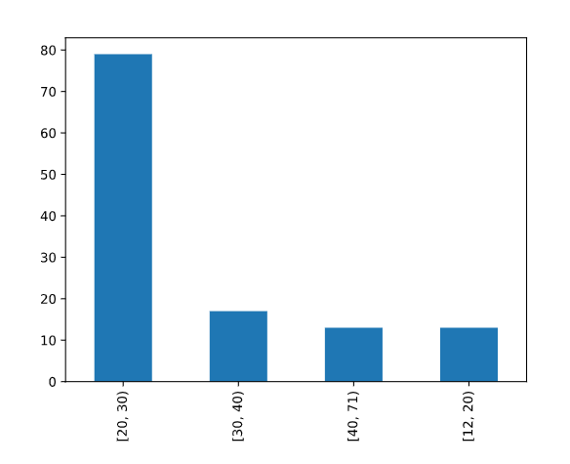

Natural Log Transformation
14 min
We’ve covered plenty of transformations! We have one last transformation we need to cover, and that is log transformations. Logarithms are an essential tool in statistical analysis and
machine learning
Preview: Docs Loading link description
preparation. This transformation works well for right-skewed data and data with large outliers. After we log transform our data, one large benefit is that it will allow the data to be closer to a “normal” distribution. It also changes the scale so our data points will drastically reduce the range of their values.

For example, let’s explore a whole new data set from Kaggle around used car prices. Take a look at this histogram plot of 100,000 used car odometers.
import pandas as pd#import our dataframecars = pd.read_csv('cars.csv')#set our variableodometer = cars['odometer']#graph our odometer readingsplt.hist(odometer, bins = 200, color = 'g')#add labelsplt.xticks(rotation = 45)plt.title('Number of Cars by Odometer Reading')plt.ylabel('Number of Cars')plt.xlabel('Odometer')plt.show();Copy to Clipboard

This histogram is right-skewed, where the majority of our data is located on the left side of our graph. If we were to provide this feature to our machine learning model it will see a lot of different cars with odometer readings off on the left of our graph. It will not see a lot of examples with very high odometer readings. This may cause issues with our model, as it may struggle to pick up on patterns that are within those examples off on the right side of our histogram.
We’ll perform a log transformation using numpy to see how our data will transform.
import numpy as np#perform the log transformationlog_car = np.log(cars['odometer'])#graph our transformationplt.hist(log_car, bins = 200, color = 'g')#rotate the x labels so we can read it easilyplt.xticks(rotation = 45)#provide a titleplt.title('Logarithm of Car Odometers')plt.show();Copy to Clipboard

Our data looks much closer to a normal distribution! If we were to look at a sample of five different cars with varying odometer readings, let’s examine how the log transformation changed their values.
make | odometer | odometer_logged
Altima | 10126 | 9.222862
Jetta | 34042 | 10.435350
Camry | 56762 | 10.946622
Civic | 100103 | 11.513955
F-150 | 145695 | 11.889271
Saturn | 151687 | 11.929574
If we compare the Altima with 10,126 miles to the Saturn with 151,687 miles those two cars have a huge difference in odometer readings. Yet, once we log transform the data we see the range from 9.22 to 11.93 is much smaller. Compressing the range of our data can help our model perform better!
There is so much more to add about log transformation. For the purpose of this exercise we just want to give a high overview and demonstrate how to log transform your data. Before we have you start testing your new skills let’s quickly cover two major topics with log transformation:
- Using a log transformation in a machine learning model will require some extra interpretation. For example, if you were to log transform your data in a linear regression model, our independent variable has a multiplication relationship with our dependent variable instead of the usual additive relationship we would have if our data was not log-transformed.
- Keep in mind, just because your data is skewed does not mean that a log transformation is the best answer. You would not want to log transform your feature if:
  - You have values less than 0. The natural logarithm (which is what we’ve been talking about) of a negative number is undefined.
  - You have left-skewed data. That data may call for a square or cube transformation.
  - You have non-parametric data
Instructions
- Checkpoint 1 PassedWe’ve imported all the necessary libraries, now you need to bring in the cars.csv file set it to a variable named cars.
- Checkpoint 2 PassedWe will be working with the sellingprice feature in this data set, so set that column to a variable called prices.
- Checkpoint 3 PassedLet’s look at a histogram of prices to check to see if it is right-skewed. Set your histogram to show 150 bins so we can see more values in our graph.
- Checkpoint 4 PassedLooks good! Now perform a log transformation on that variable prices and set the results to a variable called log_prices.
- Checkpoint 5 PassedPlot your newly log-transformed feature. Be sure to use bins = 150.
import pandas as pd import numpy as npimport matplotlib.pyplot as pltimport codecademylib3_seaborn ## add code below## read in csv filecars = pd.read_csv('cars.csv')## set you price variableprices = cars['sellingprice']## plot a histogram of pricesplt.hist(prices, bins = 150)plt.show();## log transform priceslog_prices = np.log(prices)## plot a histogram of log_pricesplt.hist(log_prices, bins = 150)plt.show();
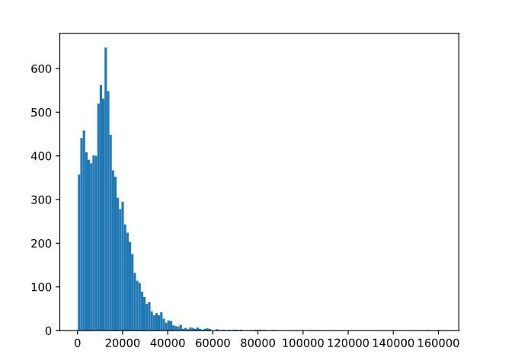

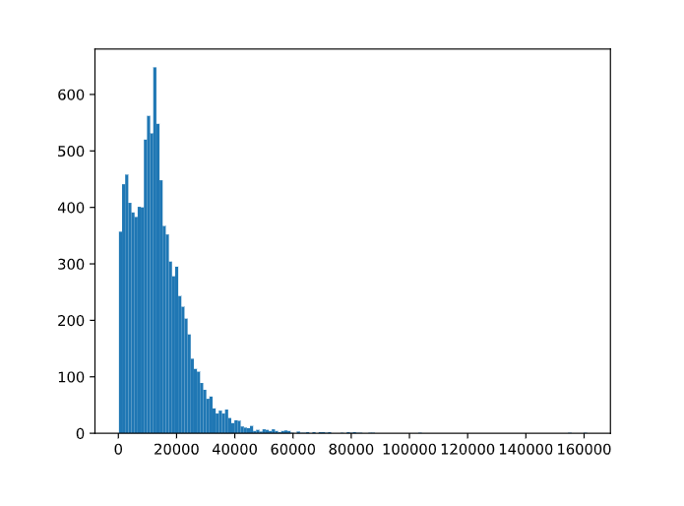

Encoding Categorical Variables
Encoding categorical variables with Python.

Introduction
Categorical data is data that has more than one category. When working with that type of data we have two types, nominal and ordinal. Nominal data is data that has no particular order or hierarchy to it, and ordinal data is categorical data where the categories have order, but the differences between the categories are not important or unclear.
We will be working with a dataset of used cars for this article to truly understand and demonstrate how to work with categorical data. Let’s explore it and see what type of data we are working with.
import pandas as pd# import datacars = pd.read_csv('cars.csv')# check variable typesprint(cars.dtypes)## OUTPUT# year int64# make object# model object# trim object# body object# transmission object# vin object# state object# condition object# odometer float64# color object# interior object# seller object# mmr int64# sellingprice int64# saledate object
We can see from the output that we have a lot of features that are dtype = object and that tells us those features could be text or a mix of text and numerical values. For our encoding examples, we will explore a few of those object features and transform those values so we can have a data frame ready for machine learning.
The reason we put our time into this level of encoding is that there are many machine learning models that cannot handle text and will only work with numbers. Our data must be encoded into numbers before we even begin to train, test, or evaluate a model.

Ordinal encoding
We mentioned already that ordinal data is data that does have order and a hierarchy between its values. Let us take a look at the condition feature from our data frame and perform a value_counts to see how many times each label is listed in our feature.
print(cars['condition'].value_counts())# #OUTPUT# New 2881# Like New 2860# Good 2027# Fair 753# Excellent 186
This is definitely an example of ordinal data: the condition of the used cars can easily be put in order of those in the “best” condition to the cars in the “worst” condition. The output printed the labels with the highest counts, but we can assume the following hierarchy:
- Excellent
- New
- Like New
- Good
- Fair
We need to convert these labels into numbers, and we can do this with two different approaches. First, we can do this by creating a dictionary where every label is the key and the new numeric number is the value. ‘Excellent’ will get the highest score and ‘Fair’ will be our lowest score. Then we will map each label from the condition column to the numeric value and create a new column called condition_rating.
# create dictionary of label:values in orderrating_dict = {'Excellent':5, 'New':4, 'Like New':3, 'Good':2, 'Fair':1}#create a new column cars['condition_rating'] = cars['condition'].map(rating_dict)
The second approach we will show is how to utilize the sklearn.preprocessing library OrdinalEncoder. We follow a similar approach: we set our categories as a list, and then we will .fit_transform the values in our feature condition. We need to make sure we adhere to the shape requirements of a 2-D array, so you’ll notice the method .reshape(-1,1).
We’ll also note, this method will not work if your feature has NaN values. Those need to be addressed prior to running .fit_transform.
# using scikit-learnfrom sklearn.preprocessing import OrdinalEncoder# create encoder and set category orderencoder = OrdinalEncoder(categories=[['Excellent', 'New', 'Like New', 'Good', 'Fair']])# reshape our featurecondition_reshaped = cars['condition'].values.reshape(-1,1)# create new variable with assigned numberscars['condition_rating'] = encoder.fit_transform(condition_reshaped)

Label Encoding
Now, we can talk about nominal data, and we have to approach this type of data differently than what we did with ordinal data. Our color feature has a lot of different labels, but here are the top five colors that appear in our data frame.
print(cars['color'].nunique())# #OUTPUT # 19print(cars['color'].value_counts()[:5])# #OUTPUT# black 2015# white 1931# gray 1506# silver 1503# blue 869
To prepare this feature, we still need to convert our text to numbers, so let’s do just that. We will demonstrate two different approaches, with the first one showing how to convert the feature from an object type to a categories type.
# convert feature to category typecars['color'] = cars['color'].astype('category')# save new version of category codescars['color'] = cars['color'].cat.codes# print to see transformationprint(cars['color'].value_counts()[:5])# #OUTPUT# 2 2015# 18 1931# 8 1506# 15 1503# 3 869
Comparing our newly transformed data to the original top 5 list, we can see Black was transformed to number 2, White was transformed to 18, and so on.
However, we have created a problem for ourselves and potentially our model. We can see that ‘Blue’ cars now have a value of 3, and our model will assume that ‘Blue’ has lower precedence over the ‘Black’ car, whose color has a value of 2. Since ‘Blue’ cars = 3 and ‘White’ cars = 18, our model could actually give ‘White’ cars 6 times more weight than a ‘Blue’ car simply because of the way we encoded this feature. To combat this ordinal assumption our model will make, we should one-hot encode our nominal data, which we will cover in the next section.
One more way we can transform this feature is by using sklearn.preprocessing and the LabelEncoder library. This method will not work if your feature has NaN values. Those need to be addressed prior to running .fit_transform.
from sklearn.preprocessing import LabelEncoder# create encoderencoder = LabelEncoder()# create new variable with assigned numberscars['color'] = encoder.fit_transform(cars['color'])
Coding question

Questions
Perform a label encoder on our make feature by changing the feature to a category type.

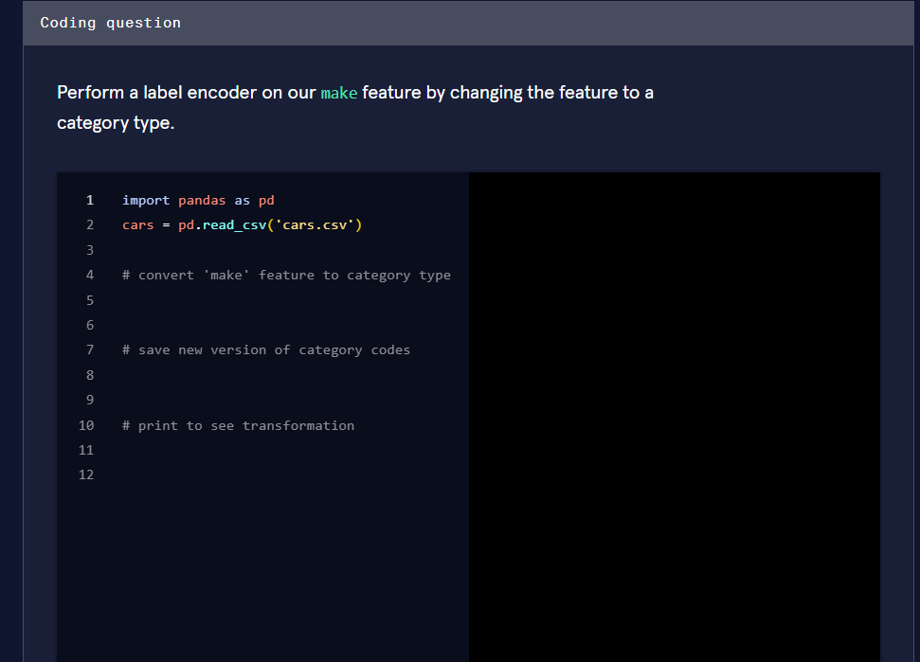

I can see you've uploaded a reference article on encoding categorical variables along with a coding quiz question. Let me help you solve it!

Coding Question: Label Encode the make Feature
Task: Perform a label encoder on the make feature by changing the feature to a category type.
Based on the technique from your uploaded reference (the "Label Encoding" section), here's the completed code:
1 import pandas as pd2 3 cars = pd.read_csv('cars.csv')4 5 # convert 'make' feature to category type6 cars['make'] = cars['make'].astype('category')7 8 # save new version of category codes9 cars['make'] = cars['make'].cat.codes10 11 # print to see transformation12 print(cars['make'].value_counts())

What's happening step by step:
Step | Code | Explanation
Line 6 | .astype('category') | Converts the make column from object (text) to pandas category dtype
Line 9 | .cat.codes | Extracts the underlying integer codes assigned to each category
Line 12 | print(...) | Displays the transformed numeric values

How it works behind the scenes:
For example, if the make column contained values like Toyota, Honda, Ford, etc., pandas assigns each unique category an integer:
Original | Encoded Code
Toyota | 5
Honda | 2
Ford | 7
... | ...

⚠️ Important caveat from your reference article:
Since make is nominal data (no inherent order between car brands), this label encoding creates the same problem discussed in the article — the model may assume that a brand encoded as 5 has more "weight" than one encoded as 2.
The article recommends one-hot encoding as a better approach for nominal data like this to avoid introducing false ordinal relationships.
Go ahead and paste that code in and hit Run to check your answer! 🚀

One-hot Encoding
One-hot encoding is when we create a dummy variable for each value of our categorical feature, and a dummy variable is defined as a numeric variable with two values: 1 and 0. We will continue to talk about our color feature from our used car dataset.
Looking at this visual below, we can see we have ten cars in four different colors. In place of the single color column, we create four dummy variables - one new column for each color. Then the values that go into that column are binary, indicating if the car in that row is the color of the column name (1) or not (0).

This approach is great for our color feature and will allow the model to see each category as its own feature and not try to create order between a “Black car” and a “Red car”. Here is how we can implement this in Python:
import pandas as pd# use pandas .get_dummies method to create one new column for each colorohe = pd.get_dummies(cars['color'])# join the new columns back onto our cars dataframecars = cars.join(ohe)
A downside to this approach is that it can create a lot of features which can then create a very sparse matrix.
Coding question
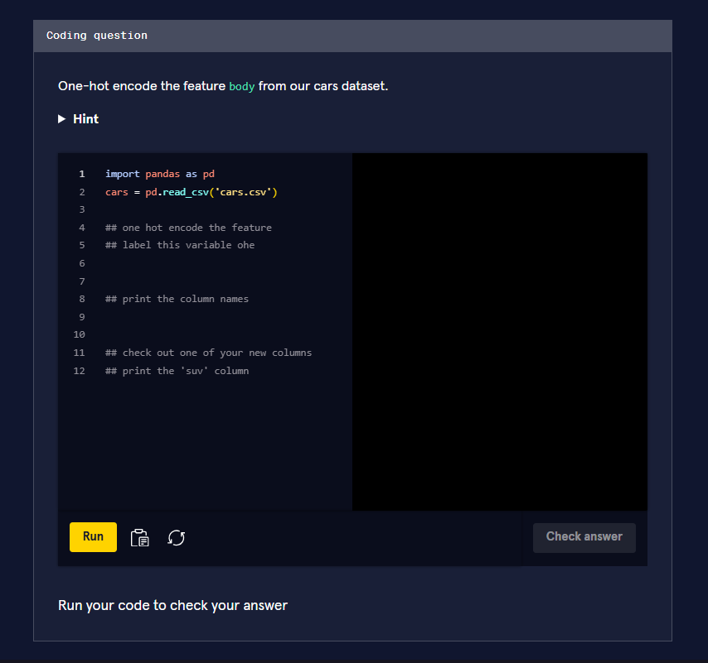
Now I can see the coding question! Building on the one-hot encoding technique from your reference material, here's the completed code:

Coding Question: One-Hot Encode the body Feature
Task: One-hot encode the body feature from our cars dataset.
1 import pandas as pd2 cars = pd.read_csv('cars.csv')3 4 ## one hot encode the feature5 ## label this variable ohe6 ohe = pd.get_dummies(cars['body'])7 8 ## print the column names9 print(ohe.columns)10 11 ## check out one of your new columns12 ## print the 'suv' column13 print(ohe['suv'])

Step-by-step breakdown:
Line | Code | Purpose
6 | pd.get_dummies(cars['body']) | Creates a new binary column for each unique body type (SUV, sedan, convertible, etc.)
9 | print(ohe.columns) | Displays all the new column names created by one-hot encoding
13 | print(ohe['suv']) | Shows the SUV column — 1 if the car is an SUV, 0 otherwise

What the output looks like conceptually:
Original | suv | sedan | convertible | coupe
SUV | 1 | 0 | 0 | 0
Sedan | 0 | 1 | 0 | 0
SUV | 1 | 0 | 0 | 0
Convertible | 0 | 0 | 1 | 0

💡 Key difference from label encoding:
As your reference notes, one-hot encoding treats each category as its own independent feature. This avoids the problem where a model might incorrectly assume an ordering relationship (e.g., that "SUV" > "sedan" because 4 > 2). Each body type gets equal, independent treatment.
Go ahead and hit Run to check your answer! 🚗

Binary encoding
If we find the need to one-hot encode a lot of categorical features which would, in turn, create a sparse matrix and may cause problems for our model, a strong alternative to this issue is performing a binary encoder. A binary encoder will find the number of unique categories and then convert each category to its binary representation. Let us take a quick review of binary numbers and keep using our color feature. We know that we have 19 unique colors, so the way to represent the numbers from 1 to 19 in binary format is as follows:
Number | Binary Number
1 | 1
2 | 10
3 | 11
4 | 100
5 | 101
6 | 110
7 | 111
8 | 1000
9 | 1001
10 | 1010
11 | 1011
12 | 1100
13 | 1101
14 | 1110
15 | 1111
16 | 10000
17 | 10001
18 | 10010
19 | 10011
We can easily see that our highest number 19 is 5 digits long, so our binary encoder will need 5 columns to be able to represent all digits. Here is a sample of how our color column will transform each color if we were to perform a binary encoder.

Our 19th color, pink, has transformed to be represented in the binary form 10011. If we were to utilize this process instead of the traditional one-hot encoder we would have 5 numerical features instead of 19, reducing our features by about 75%!
To make this happen with Python we’ll use a library called category_encoders and import BinaryEncoder. We will determine which column to transform and set drop_invariant to True so it will keep the five binary columns. If it is set to the default 0, then we would have an additional column full of zeros.
from category_encoders import BinaryEncoder#this will create a new data frame with the color column removed and replaced with our 5 new binary feature columnscolors = BinaryEncoder(cols = ['color'], drop_invariant = True).fit_transform(cars)

Hashing
Another option we have available to us is an encoding technique called hashing. This process is similar to one-hot encoding where it will create new binary columns, but within the parameters, you can decide how many features to output. A huge advantage is reduced dimensionality, but a large disadvantage is that some categories will be mapped to the same values. That is called collision.
For example, we have 19 different colored cars. If I were to use the hash encoder and set the number of features to be 5, I will definitely have a few colors with the same hash values.

We can easily see that brown and charcoal colors have the same hash values. Meaning, we’ve lost some information and our model won’t be able to see the difference between those two colors.
Here is how we can make this work with Python. Our final result of hash_results will produce a data frame of just 5 columns, so we will want to concatenate this new data onto our original data frame.
from category_encoders import HashingEncoder# instantiate our encoderencoder = HashingEncoder(cols='color', n_components=5)# do a fit transform on our color column and set to a new variablehash_results = encoder.fit_transform(cars['color'])
Now you may be thinking, when would I use this if I’m going to lose information and my model will see brown and charcoal (or some other color combo with the same hash value) as the same thing? Well, this could be a solution to your project and dataset if you are not as interested in assessing the impact of any particular categorical value.
For this example, maybe you aren’t interested in knowing which color car had an impact on your final prediction, but you want to be able to get the best performance from your model. This encoding solution may be a good approach.

Target encoding
Target encoding is a Bayesian encoder used to transform categorical features into hashed numerical values and is sometimes called the mean encoder. This encoder can be utilized for data sets that are being prepared for regression-based supervised learning, as it needs to take into consideration the mean of the target variable and its correlation between each individual category of our feature. In fact, the numerical values of each category is replaced with a blend of the posterior probability of the target given a particular categorical value and the prior probability of the target over all the training data.
Woah, now that was a lot of Bayesian buzzwords. How would it work with our specific color feature? It replaces each color with a blend of the mean price of that car color and the mean price of all the cars. Had it been predicting something categorical, it would’ve used a Bayesian target statistic.
Some drawbacks to this approach are overfitting and unevenly distributed values that could lead to extremes. Let’s review how to implement this in Python and check out what type of numerical values it will return. Again, we’ll continue with our color feature - hope you are not yet tired of it!
Say we are preparing our dataset for a regression-based supervised learning algorithm that is trying to predict the selling price.
from category_encoders import TargetEncoder# instantiate our encoderencoder = TargetEncoder(cols = 'color')# set the results of our fit_transform to a variable # the output will be its own pandas seriesencoder_results = encoder.fit_transform(cars['color'], cars['sellingprice'])print(encoder_results.head())# color# 0 11761.881473# 1 18007.276995# 2 8458.251232# 3 14769.292595# 4 12691.099747
We can examine all the different values our encoder_results holds, and if we look at the output from below we can see our min is about 3,054 and our max is about 18,048. That is quite a big difference!
# print all 19 unique valuesprint(np.sort(encoder_results['color'].unique()))# OUTPUT # [ 3054.12209927 8088.87434555 8458.25123153 9276.78571429# 9867.50002121 9885.8093167 11043.90243902 11247.82608763# 11761.88147296 11805.06187625 12124.83443709 12376.19047882# 12691.09974747 13912.83399734 14769.29259451 15496.72704715# 17174.36440678 17176.25931731 18007.27699531 18048.52540833]

Encoding date-time variables
Every data analyst or scientist will have to work with date-time objects at some point in their career. There is so much information to be gained from date-time objects. We will work with the saledate feature - yay, a new column to explore! The very first thing we need to do is convert this to a date-time object.
print(cars['saledate'].dtypes)# # OUTPUT# dtype('O')cars['saledate'] = pd.to_datetime(cars['saledate'])# #OUTPUT# datetime64[ns, tzlocal()]
Now that we have our feature set up as a datetime object, let’s demonstrate some methods we can utilize to get additional information.
# create new variable for monthcars['month'] = cars['saledate'].dt.month# create new variable for day of the weekcars['dayofweek'] = cars['saledate'].dt.day# create new variable for difference between cars model year and year soldcars['yearbuild_sold'] = cars['saledate'].dt.year - cars['year']
Below are other options available through pandas .dt
Syntax | Description & Output
df[‘col’].dt.year | Outputs the year
df[‘col’].dt.day | Outputs the day number
df[‘col’].dt.hour | Outputs the hour from the time
df[‘col’].dt.minute | Outputs the minute from the time
df[‘col’].dt.second | Outputs the seconds from the time
df[‘col’].dt.week | Outputs the week ordinal of the year
df[‘col’].dt.dayofweek | Outputs the day of the week with Monday = 0 & Sunday = 6
Additional methods can be found here.

Review
Wow, we covered a lot in this article! You have so many options when it comes to transforming categorical data into numerical values. We touched in:
- Ordinal encoding
- Label encoding
- One-hot encoding
- Binary encoding
- Hashing
- Target encoding
- Date-time encoding
We hope you can see the importance of getting your categorical features just right before you begin to train and test a model.

